1. LOAD CELL SENSOR  
   Load cells are simply, transducers that have the ability to translate pressure (mechanical force) into electrical signals. This can be achieved in different ways as evident in the way they have been set up. The first way is the hydraulic load cell which makes use of a conventional piston with an arrangement of cylinders to indicate a change in pressure when the piston and the diaphragm moves to produce a change in the pressure. Another way is the pneumatic load cells which engages air pressure to one end of a diaphragm so it escapes through the nozzle positioned at the bottom of the load cell with a pressure gauge inside the cell. The last way is strain gauge load cell, a mechanical element which senses the force caused by the deformation of the strain gauge on the element.

The set up used in the project consists of four resistors arranged in parallel and connected to an amplifier to amplify the electrical signal generated. These resistors have been positioned under a speed ramp few meters before the toll station. This electrical signal will further trigger the microcontroller to activate the entire system.

This device is used due to the fact that it is insensitive to temperature variations as well as being explosion proof.

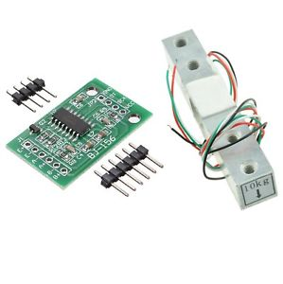

1. ZIGBEE MODULE

Zigbee is a standard from the IEEE 802.15.4 used in creating personal area networks with small powered digital radios including home automation purposes and other small-scale project requiring the use of wireless connections. This is to say Zigbee is low powered and requires close range with the communicating device. It is also simpler and cost less than other Wireless Personal Area Networks such as the IEEE 802.11 WIFI standard. It is employed in this project due to its numerous benefits including;

* It supports a number of nodes which is necessary as we are assigning a module each for every registered vehicle.
* Its simple nature makes it easy tot install
* Its less complicated than other standards Wireless Personal Networks including IEEE 802.15(Bluetooth)
* I

• Zigbee has a flexible network structure

• It has very lone battery life

• Zigbee has a mesh network topology with low cost, multi hope data transmission and is power effective

• It is less complex than bluetooth

• It is easy to install

• Zigbee support large number of nodes

• Zigbee is more reliable

• It is short working period result in power savi

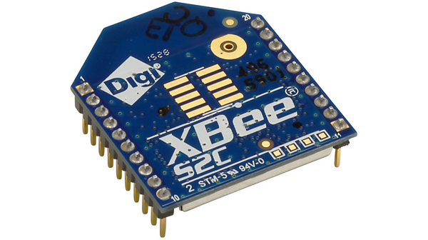

1. GSM MODULE

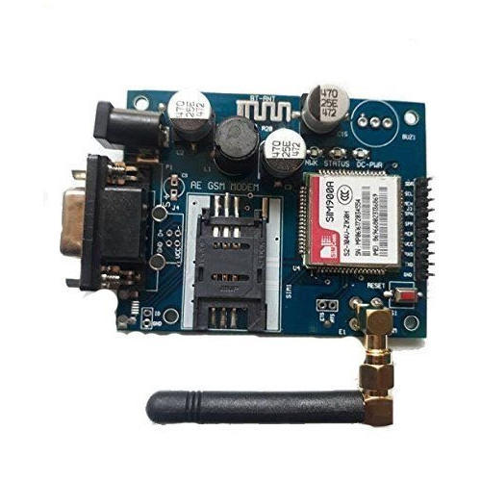

1. SERVO MOTOR

